Karatsuba Multiplication Algorithm

Karatsuba multiplication algorithm is an algorithm used for faster multiplication. This algorithm uses divide and conquer paradigm.

So, given numbers let’s say, x=5678 and y= 1234

We can split a number in two, in the following way

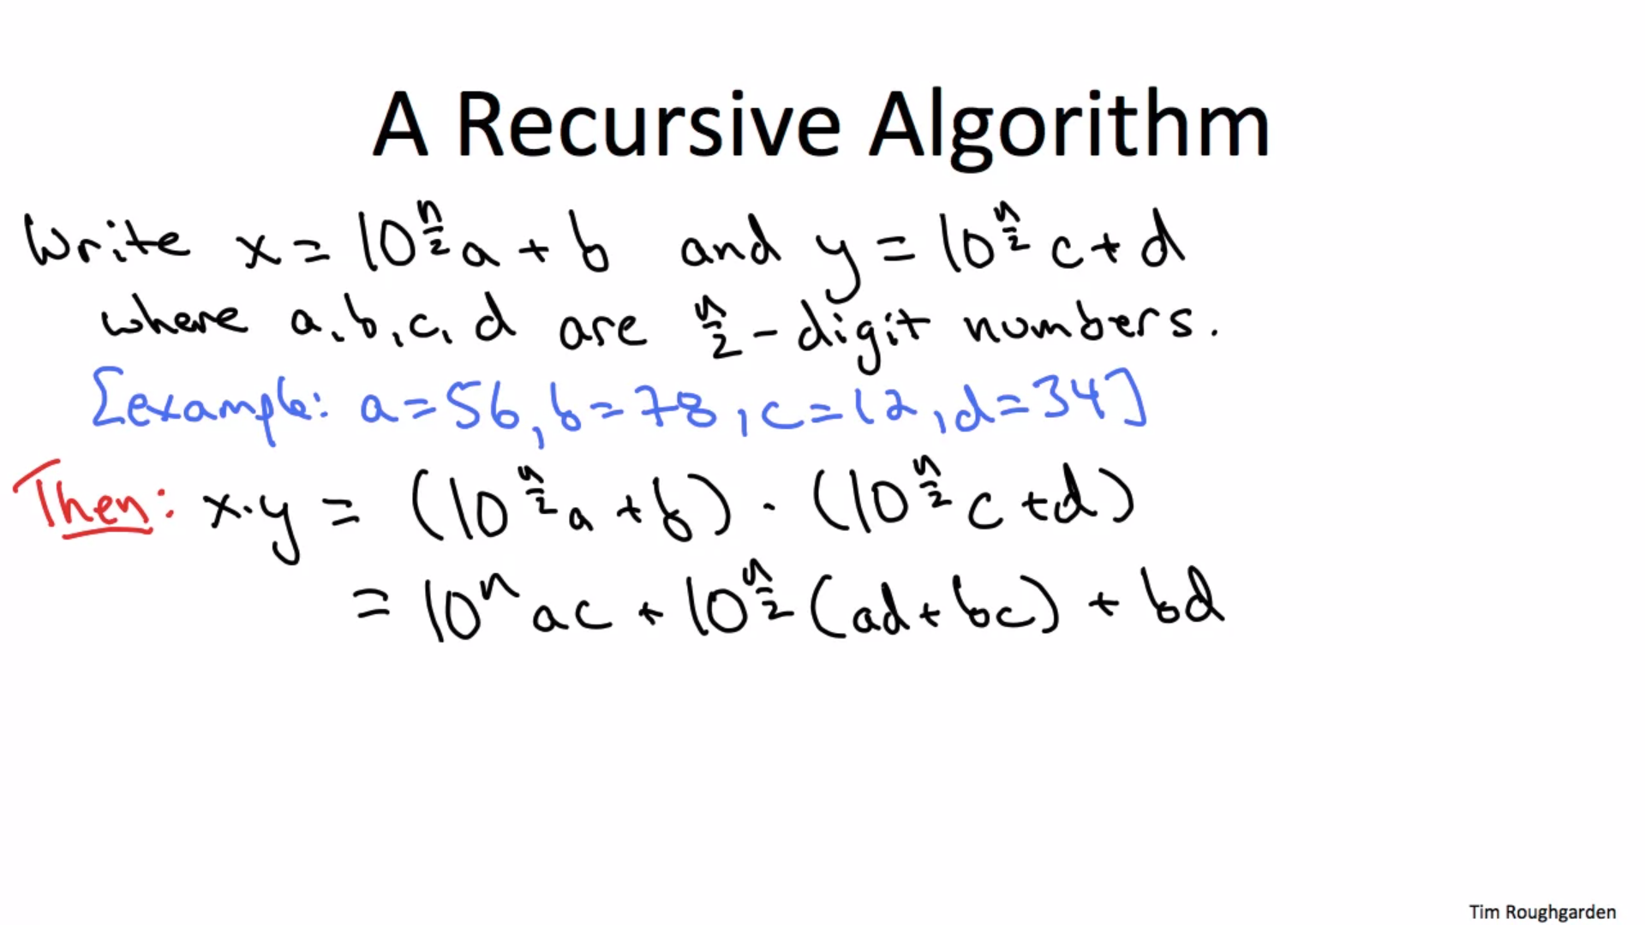

The logic for splitting the number is in the code.